#### **Replace All After/Before Specific Character Or Space With Find And Replace Feature**

This method will introduce the Find and Replace feature to easily replace all characters after or before specified one in Excel. Please do as follows:

1. Select the list you will replace all after/before the specific characters, and press the **Ctrl** + **H** keys simultaneously to open the Find and Replace dialog box.

**Note**: You can also open the Find and Replace dialog box by clicking **Home** > **Find & Select** > **Replace**.

**2**. In the Find and Replace dialog box, please do as follows：  
(1) In the**Find what** box, please type b*;

**Note**: b is the specific character you will replace all characters after. To remove all before the specific character, please type *b into the **Find what** box. To replace all characters after (before) space, please type a space and * (or * and a space) into this box.

(2) In the **Replace with** box, please type the text string you will replace with.  
(3) Click the **Replace All**button.  
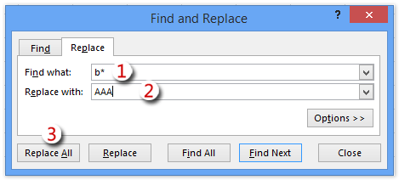

**3**. Now a dialog box will come out and show how many replacements it has made. Just click the **OK**button to close it. And then close the Find and Replace dialog box.  
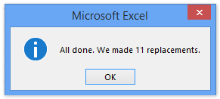

And now in our example you will see all characters after b has been replaced with the specified text in the selected cells. See screenshot:

**Note**: This method does not work if you want to replace all characters after/before wildcards (* and ?).